# Hardware Assembly

## MCU Installation

The Micro-Controller Unit (MCU) should be mounted in the enclosure as shown in Figure 1. Ensure that the MCU board is fully seated before tightening the screws.

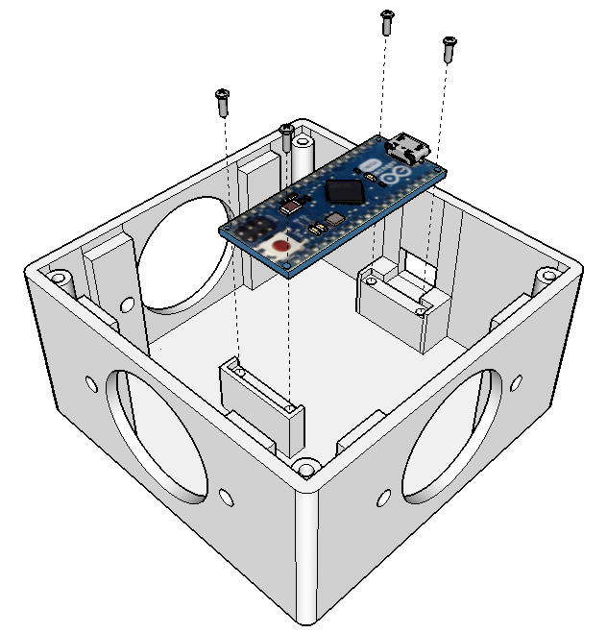

Figure . Exploded View of MCU Mounting

## Octal Socket Installation

Each 8-pin octal socket should be installed using the 4-40 screws as shown in Figure 2 with a lock washer behind the socket flange, followed by a hex nut. The notch in the center hole of the socket should point to the right when viewed from the outside of the enclosure, see Figure 3.

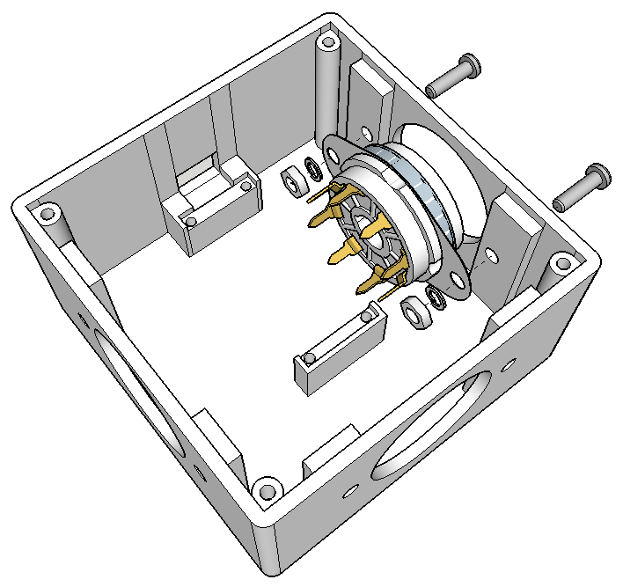

Figure . Exploded View of Octal Socket

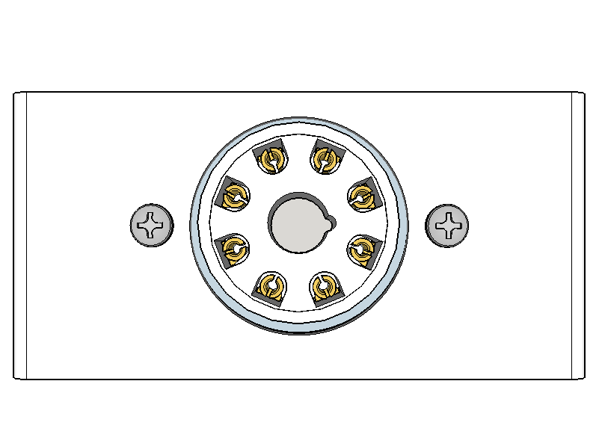

Figure . Correct Orientation of Octal Socket (Viewed from Exterior of Enclosure)

The enclosure with the MCU mounted and all three octal sockets in place should look like Figure 4.

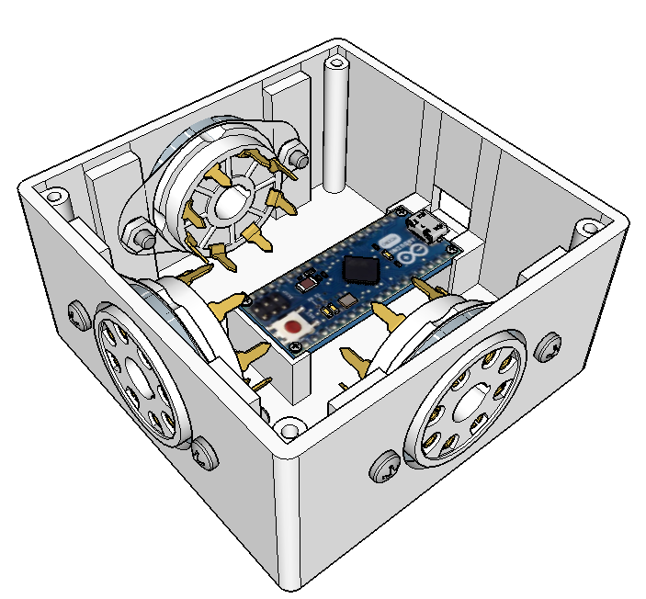

Figure . Enclosure with MCU and Octal Sockets Mounted

## Wiring The Unit

Pins on each octal socket will need to be connected to the MCU. One pin from each of the sockets will connected to common, or ground on the MCU (GND) using a length of 28 - 32 gauge insulated wire. Five pins from each of the sockets will be connected to individual pins on the MCU using 1/6 Watt 10 KΩ resistors, which provide some input protection for the MCU pins. Sockets are referred to as Socket I, Socket II and Socket III according to Figure 5

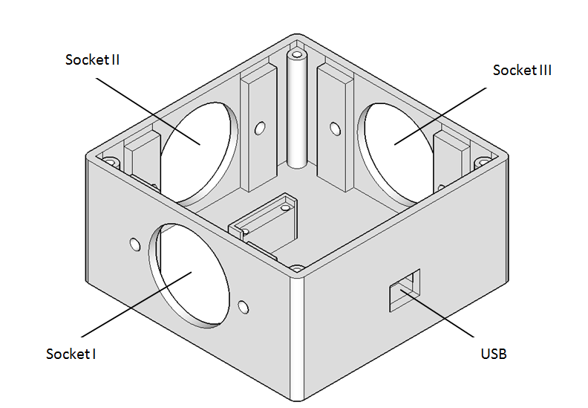

Figure . Enclosure Showing Socket Designations

The pins on each socket are numbered 1 - 8 as shown below (octal socket as viewed from the exterior of the enclosure).

2

1

3

4

5

6

7

8

The pins on the MCU are labeled on the MCU board. See the image below for reference.

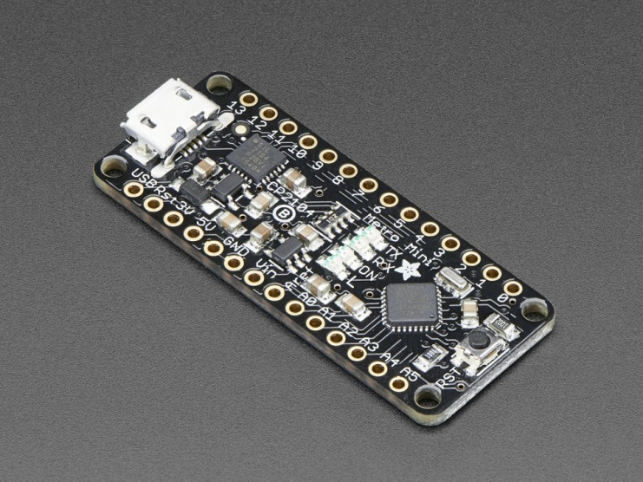

Figure . Adafruit Metro Mini MCU showing pin numbers.

The correct wiring order for each socket pin to each MCU pin is detailed in Table 1.

|  |  |  |  |  |  |
| --- | --- | --- | --- | --- | --- |
| Socket I | | Socket II | | Socket III | |
| Socket Pin Number | MCU Pin | Socket Pin Number | MCU Pin | Socket Pin Number | MCU Pin |
| 1 | 12 | 1 | 2 | 1 | A4 |
| 2 | 11 | 2 | 3 | 2 | A3 |
| 3 | 10 | 3 | 4 | 3 | A2 |
| 4 | 9 | 4 | 5 | 4 | A1 |
| 5 | 8 | 5 | 6 | 5 | A0 |
| 6 | GND | 6 | GND | 6 | GND |

Table . Socket Pin to MCU Pin Wiring Order

Pin 6 on Sockets I, II and III can be tied together and then a single connection made to the GND pin on the MCU from pin 6 on Socket III.

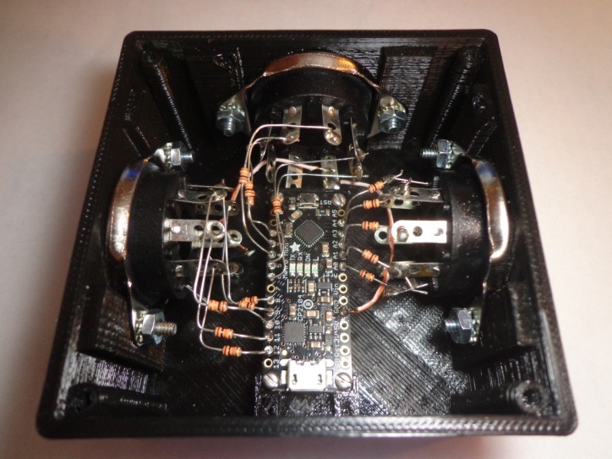

Figure . Completed Wiring

## USB Cable Installation

The USB Micro-B end of the USB cable can be connected to the MCU through the opening in the wall of the enclosure. Note that the housing of the USB Micro-B plug may need to be trimmed to fit through the opening. To prevent sudden force on the USB cord from tearing the USB jack on the MCU from the MCU board, hot glue or similar adhesive can be used to permanently secure the USB plug housing to the enclosure.

## Lid Installation

## C:\Users\Elijah\Google Drive\Quiz Box\Documentation\Images\Enclosure with Lid Exploded.png

Figure . Exploded View of Enclosure with Lid and Screws

# Software Installation

## Firmware Installation

To install the firmware on the MCU, the Arduino IDE is required.

Arduino IDE cloud based and Windows versions:

<https://www.arduino.cc/en/main/software>

## Driver Installation

To communicate with the MCU from a PC via virtual COM port, drivers for the Windows OS may need to be installed.

USB to UART bridge VCP drivers from Silicon Labs:

<http://www.silabs.com/products/development-tools/software/usb-to-uart-bridge-vcp-drivers>

The following driver from FTDI may also be required:

<http://www.ftdichip.com/Drivers/VCP.htm>

## Client Software Installation

ToDo provide links for Quiz Machine and Virtual Blue Box software packages.